Minor Project (BTCS607N) Weekly Progress Report (Week-3)
Project Title: Vaari - Crop Water Footprint Information App
Phase 2 — Object-Oriented Analysis
Goal: Perform static analysis by identifying domain objects, showing a sample object snapshot, and preparing the initial class diagram for the Vaari system.
1. Introduction
- Week 3 focuses on static analysis of the Vaari application.
- This week is used to identify the important objects in the system and understand the relationships among them.
- The deliverables for this week are the object diagram and the initial class diagram.
2. Object Diagram
- The object diagram shows a snapshot of real instances of the system at a specific point in time.
- For Vaari, the object diagram can show an example crop object such as Wheat with its water footprint value and category.
- It can also show a search history object with crop name and timestamp.
- The object diagram helps to understand how actual values are stored in the system.

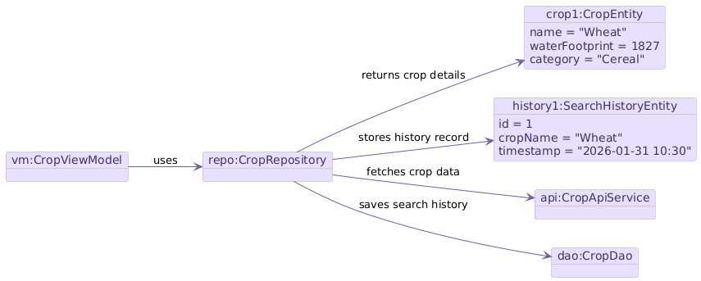

3. Initial Class Diagram
- The initial class diagram shows the main classes of the system and their structural relationships.
- CropViewModel communicates with CropRepository.
- CropRepository communicates with CropApiService for crop data and with CropDao for local history storage.
- CropDao is linked to SearchHistoryEntity, while CropEntity represents crop details such as name, water footprint, and category.

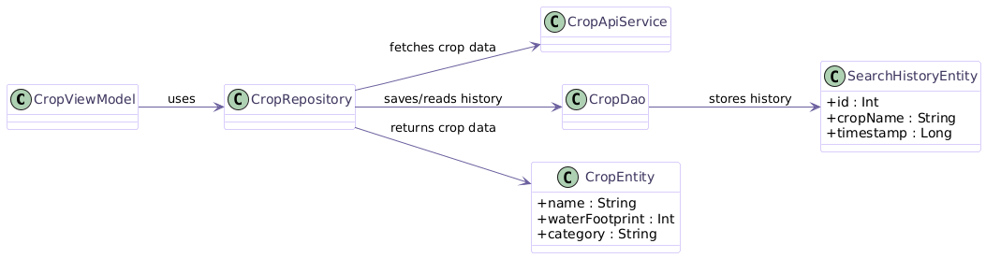
4. Identified Classes and Attributes
- CropEntity: name, waterFootprint, category.
- SearchHistoryEntity: id, cropName, timestamp.
- CropViewModel: manages UI data flow.
- CropRepository: coordinates data from API and local storage.
- CropApiService: fetches crop data from backend.
- CropDao: stores and retrieves search history.
5. Scope of Week 3
- Week 3 is limited to object and class modeling.
- No method-level implementation or detailed design is done yet.
- This week prepares the foundation for detailed design in later weeks.
6. Deliverables
- Object diagram.
- Initial class diagram.
- List of domain entities and their attributes.
7. Expected Outcome
- A clear snapshot of the system objects.
- A static structural model that can be refined in later weeks.
- A strong base for detailed class design and implementation.

8. Team Roles
- Team members will work on identifying objects, drawing class relationships, and preparing the Week 3 documentation.

Mentor Signature ___________________Project Guide Signature _____________________

